|  |  |  |
| --- | --- | --- |
| **شعار جامعة بنها الجديد**f |  | **logo.jpg** |
| Benha University |  | Faculty of Computers & Informatics |

**Genius Pharmacy**

An Information System project submitted in partial fulfillment of the requirements for the degree of Bachelor of Computers and Informatics.

**2nd Year Student IS**

*Project Team*

1. Ahmed Mohey Younis

Section 3

Benha, December 2018

**Abstract**

Genius Pharmacy is a program that build for Information System that sells medicines and allow people to search for the suitable medicine.

If you have a pharmacy you can use this program to manage it and hire pharmacists to work with it.

**Introduction**

For the begging , you run the program you will have to enter your account if you are a pharmacist works for the pharmacy or enter your name if you are a visitor wants to search for a specific medicine but if you are the owner of the pharmacy you will have admin acces to manage the program in the admin frame you can add employees and medicines you also can manage them and see your employees work and statistics of profits and view the people who searched for medicines with your program.  
some features are allowed to pharmcist frame but there is difference because pharmacists have attendance and leaving , pharmacists can sell medicines and print bills...

**Program Interface**

**At the beginning the user will able to login as Pharmacist , Admin, Guest..**

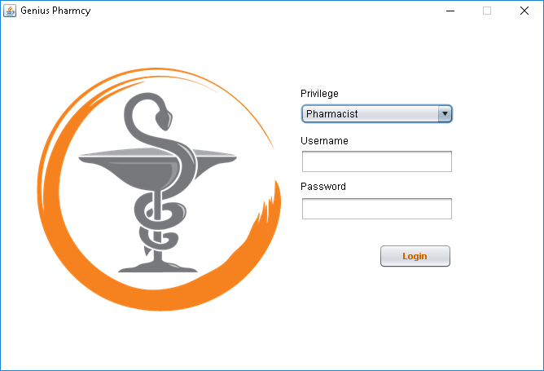

**This frame will open if you logged as admin**

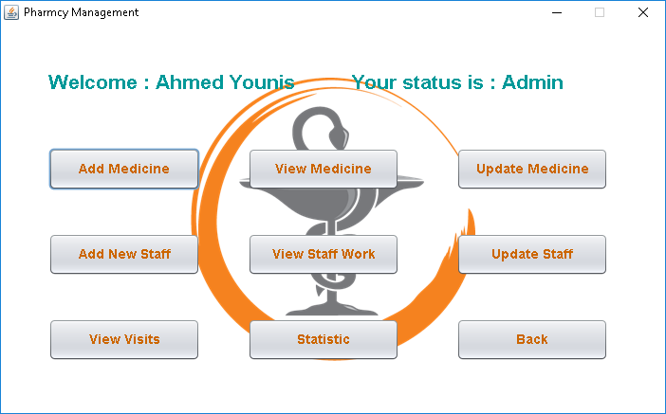

**You can here use many features…  
if you press the Add Medicine button this frame will open**

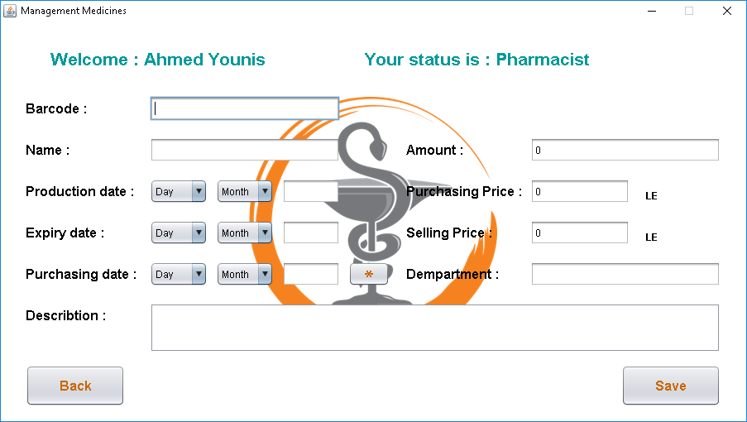

**If you press the update medicine button this frame will be opened**

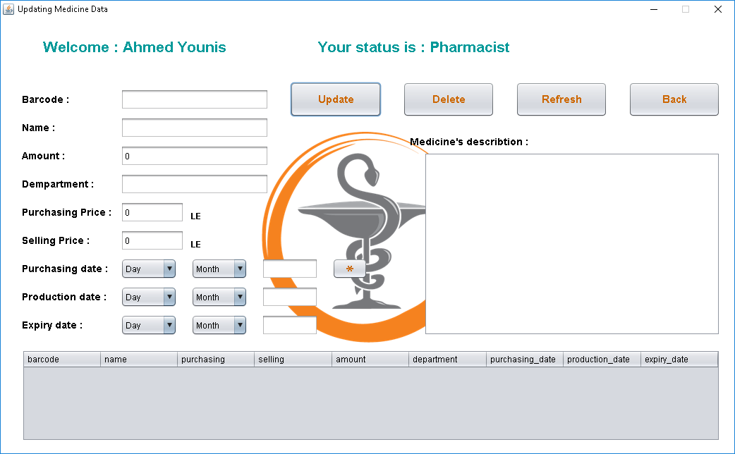

**If you press add staff button this frame will be opened 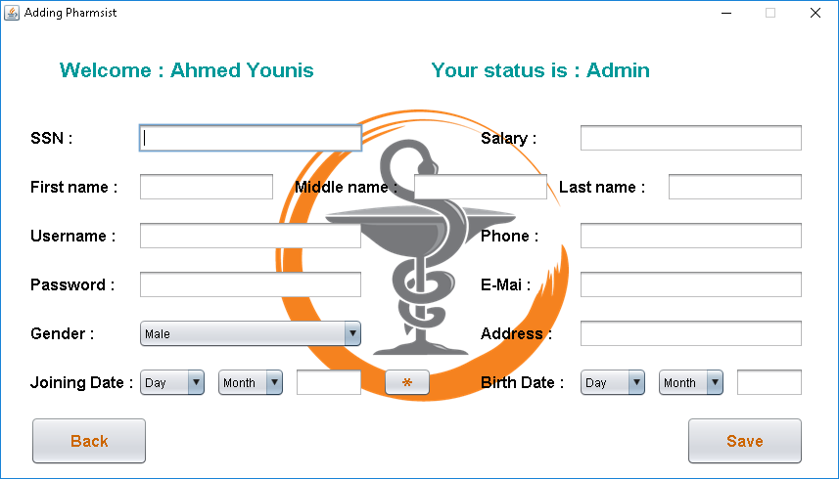if you press update staff button this frame will be opened**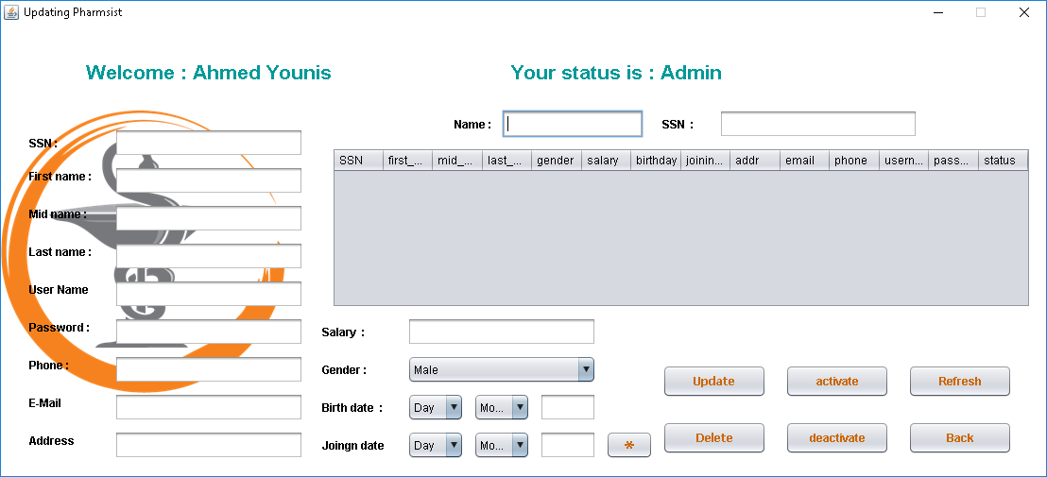

**You can view the staff work and statistic profit from these 2 frames** 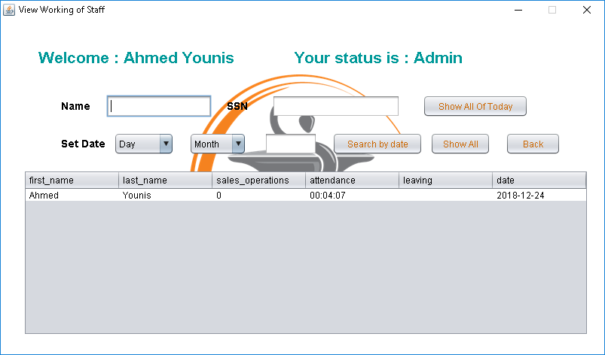

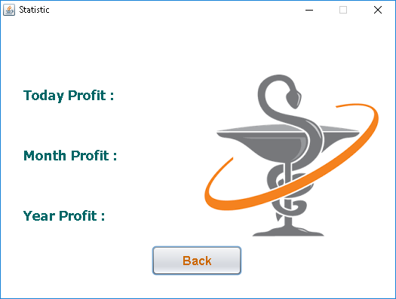

**You can view visits of guests here** 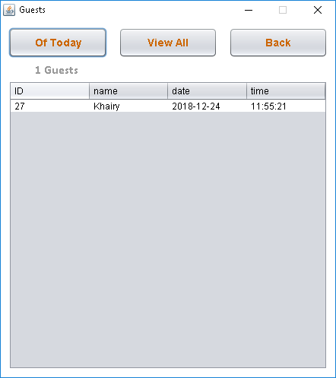

**This frame will open if you logged as pharmacist**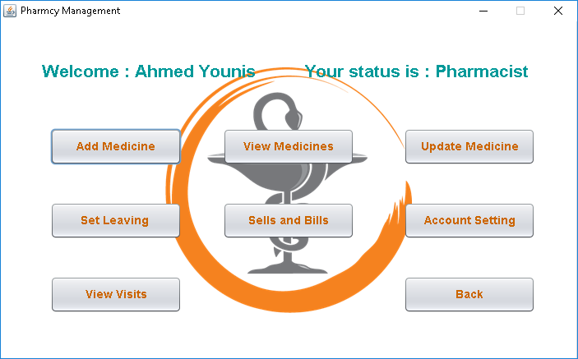

**Here you can manage your account** 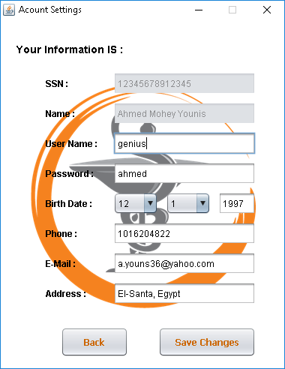

**And set leaving from here** 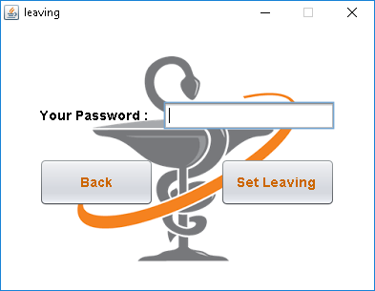

**In this frame you can sell medicines and make bills**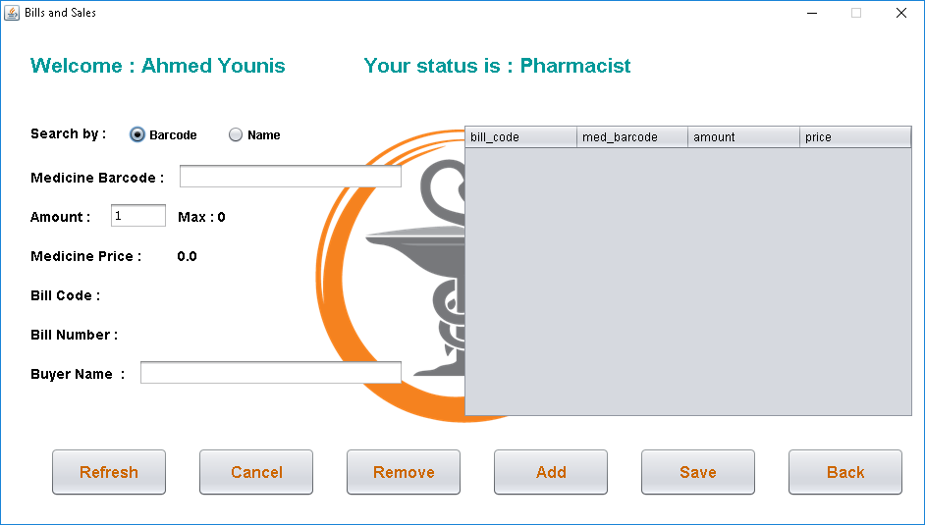

**Frome here you can brint your bill** 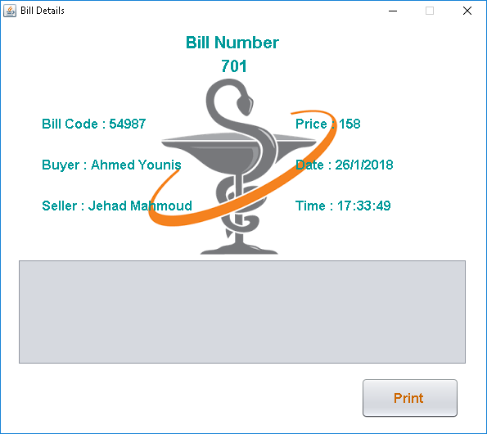

**And if you logged as guest or wants to search for medicines as admin or pharmacist you can use this frame** 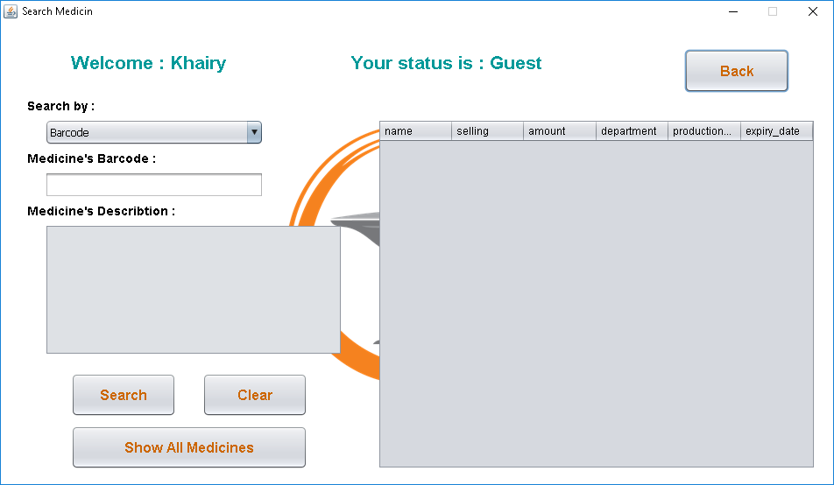

**Program Execution**

**As you can see here is the classes that execute inside**

**The program**

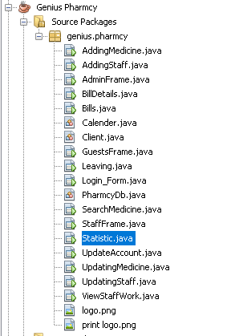

**To see the code you can open this javdoc.**

[**Genius Pharmcy\dist\javadoc\index.html**](Genius%20Pharmcy/dist/javadoc/index.html)

**Difficulties Encountered**

Working Alone

Recycling the database

Design issues

**Conclusion**

Shortly if you have a pharmacy you should use Genius Pharmacy. It can Manage your pharmacy , your employees, your visitors , your bills and also show you statistics of your profit